LMS Online Quiz –

Question Bank Organization

A question bank in LMS is an overall stock of all the questions and tasks you’ve ever created on the platform. This feature saves time since there’s no need to create everything from scratch: if you need to prepare a test for a new course, you can simply copy ready-made tasks from the bank.
Click on the link of “Question Bank” available in the left block of the course.

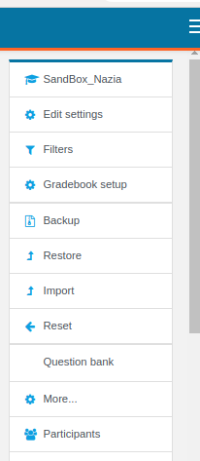
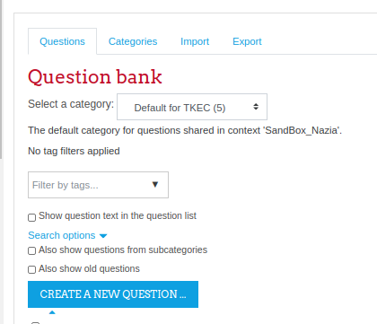

1. Question Bank Categories
Questions are organised into categories. Initially each course has only one category called "Default". It is good practice to create more categories to organize your questions. This not only makes it easier to find questions, but makes the use of random questions and matching questions easier. You can create a hierarchy of categories because you can create subcategories inside parent categories.
- To add or edit categories click on the "Categories" tab.
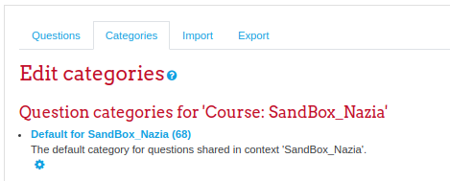

- Access the “Add category” section and select the parent category.
- Write name and description of the category and click on the “Add category” button.
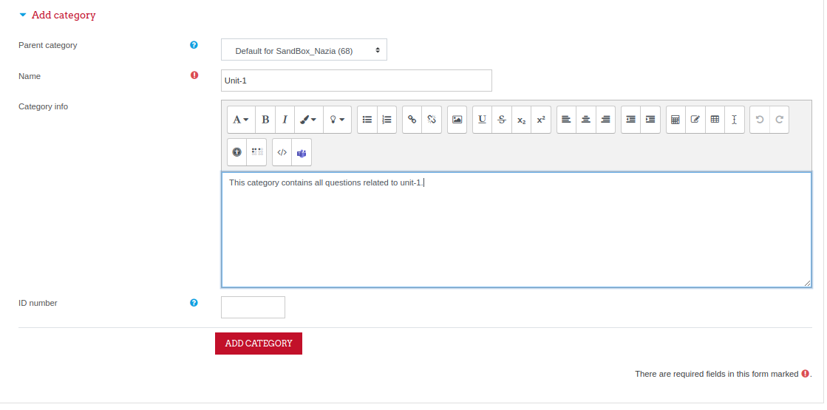
- The subcategory is created under the selected parent category of the question bank.
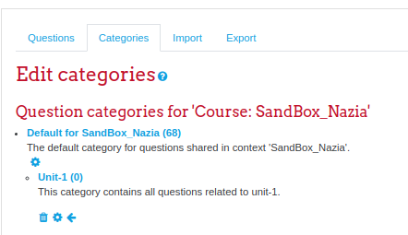

2. Add Questions into Question Bank
- Select any sub-category or the default category of the question bank to create questions in it.
- Click on the button “Create new question” and add new questions using the method already explained in the separate manual.
- A question of the question bank can be edited using the “Edit” icon and can be duplicated using the “Duplicate” icon.
- You can preview each question of the question bank in “Adaptive mode” to have an idea about the grades computation upon correct and incorrect answers by the students. Click on the “preview” icon (magnifying glass).
- Single or multiple questions can be deleted from the question bank using the “Delete” icon.
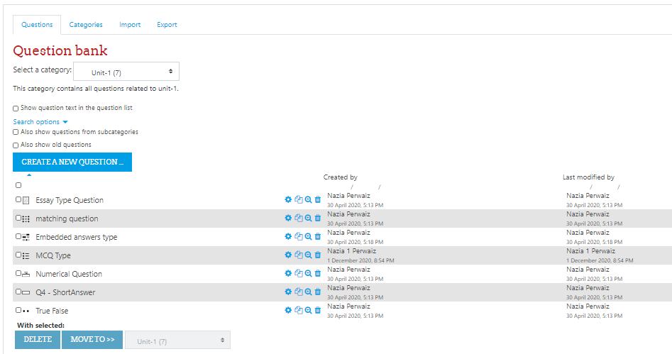

- All questions of a category can be exported as a file and can be reused in any other course.

__________________________

